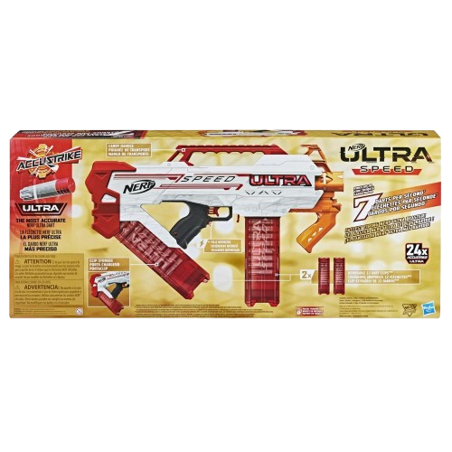****

**Nerf Ultra**

**Price: $19.99**

**Experience the extra range of Ultra**

**Ergonomically designed for better handling and control.**

**The Nerf Ultra series is a cutting-edge line of blasters that offers exceptional performance, designed for ultimate distance and precision. Featuring the all-new Nerf Ultra darts, which are designed with improved aerodynamic technology, these blasters can shoot darts up to 120 feet**

**.**

.

**Product details**

**THANK YOU!**

**WELLCOME TO OUR WEBSITE**